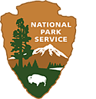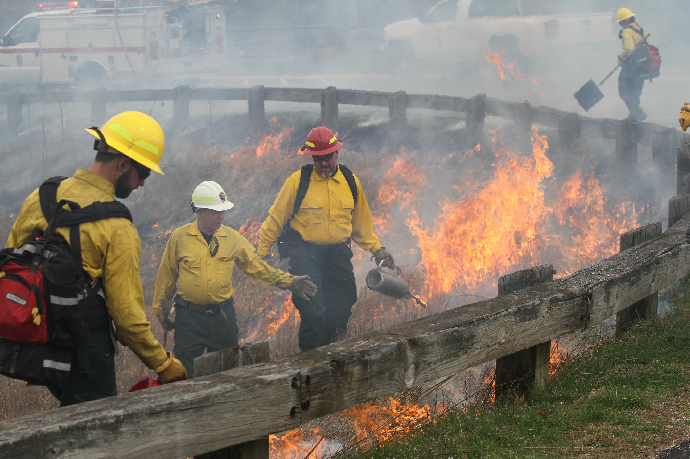

Mount Rushmore National Memorial

National Park Service

U.S. Department of the Interior

Fire Ecology

How prescribed burns help our ecosystem

Table of Contents

# Introduction pg. 3

# Testing the Conditions Activity pg. 5

# Activity worksheet pg. 6

# References and Resources pg. 7

Introduction

# **Theme**

Fire is a powerful tool used by trained professionals to keep ecosystems in the Black Hills safe and healthy.

# **Education Standards**

## SD 5th Grade

5-ESS3-1 Obtain and combine information about ways individual communities use science ideas to protect the Earth’s resources and environment. (SEP:8; DCI: ESS3.C; CCC: Systems)

# **Activity**

Testing the Conditions: Students will use the set of conditions that fire experts test for to see if they could theoretically conduct a prescribed burn. They’ll measure temperature, wind speed, and moisture contents.

# **Key Vocabulary**

Prescribed Burn, Wildland firefighter, Fuels, Anemometer, Reforestation, Restorative, Combustion

# **Objectives**

Students will learn that fire can be a useful tool and be able to define what a prescribed burn is; they will be able to describe some of the conditions needed for a prescribed burn.

# **Background**

Fire, especially wildfire, has a reputation. We hear about wildfire breaking out and worry what is going to happen. Begin with asking students what comes to mind when they think of fire and write their answers down on the board.

Note the tone of their responses. Are they bad? Scary? What’s their view on fire - is it something to be afraid of?

Their responses are all valid, but we want to show that there can be a positive side to wildfire too. While wildfire can be scary, it can also be a restorative tool if used in a safe and proper way by trained professionals.

This is where “prescribed burns” are useful tools. What exactly is a prescribed burn? A team of fire experts, sometimes called wildland firefighters, intentionally set fire to a specific area to manage the forest. A specific set of conditions need to be met for a prescribed burn to happen safely, and we’ll cover those conditions in a bit. There are many reasons prescribed burns help manage an area:

* Prepares the area for reforestation, the act of replanting trees
* Reduces forest fire risk and intensity of forest fires
* Eliminates flammable fuels. Flammable fuels are anything that can be burned, like down trees, excess shrubs, tall grasses, plants, etc.
* Species that are fire dependent get reintroduced to the area, like some pine, maple, and fir trees
* Fire destroys weeds and parasitic plants to decrease competition for nutrients
* Kills pests and pathogens of tree diseases (like the pine beetle here in South Dakota)
* Releases nutrients from burnt plants to improve soil health
* Refreshes grasses for grazing animals, making more food in the area

We see that there are many reasons to safely create fire in an area. We can minimize the impacts of damaging wildfire and bring good nutrients back to the plants. Animals benefit from fresh grown grasses. When they graze on these grasses, they further help the burned area become healthy again.

But we keep mentioning that this is only good if it’s done safely. There are risks to consider such as:

* Fire can get out of control, and flames can escape. We can’t predict how fire will burn 100% of the time.
* Health of the surrounding neighborhoods and towns, will the smoke hurt people?
* There’s a possibility of destroying plants and wildlife that are not the target of the burn

These are important things wildland firefighters also must consider. To be safe there are many things they measure.

* Air temperature: higher temperatures mean fire combusts faster. Colder temperatures give more control over combustion rate. Ideal condition, 40-60F
* Surface wind: wind that we feel standing on the ground. The speed and direction need to be stable to avoid flames escaping. Ideal condition, 1-3 mph
* Transport wind: this is the wind speed 20 ft above the surface, and it must be strong enough to disperse smoke. Ideal condition, 6-18 mph
* Relative humidity: the moisture content in vegetation affects flammability. Too humid of air means the fuels won’t burn or will produce too much smoke. Too little humidity will cause fuels to ignite too fast. Ideal condition, 40-55%
* Precipitation: How moist the soil is helps prevent root damage and undersurface ignition. Ideal condition, 1 inch.

These conditions are not universal, they vary based on the changing of other factors and by region but give us a solid starting point.

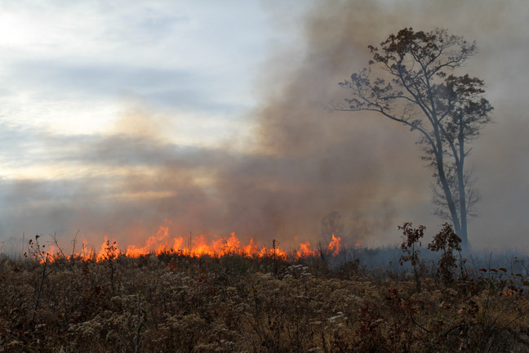

An example of the smoke that rises from prescribed burns. These are the conditions that could affect surrounding communities. NPS/Jonathan Shafer

Testing the Conditions

# **Duration**

~15 Minutes

# **Location**

Outdoors

# **Objectives**

Students will learn to take measurements on weather and infer choices from that data.

# **Method**

By going outside and hands-on taking the temperature, seeing the wind speed, and reading a weather report, students will record the data on their worksheet and determine if conditions are good for a burn.

# **Materials**

Worksheet, thermometer, anemometer, printed out weather report for the week (must include precipitation, wind speeds), pen or pencil.

# **Suggested Procedure**

1. Show students the tools they’ll be using. The thermometer for temperature, and the anemometer as a tool to measure the wind speed.

2. Hand out worksheets

3. Go outside and have students split into groups. Size of groups determined by the tools available so everyone can get a chance to use them.

4. Once the data is collected, head inside and debrief.

5. Debrief questions

· Based on the conditions you recorded, would it be safe to burn today?

· What are some safety concerns to be aware of? The surrounding community?

· Return to the initial question in the lesson. What do the students think of fire now? Hopefully their responses show they can see the benefits of fire.

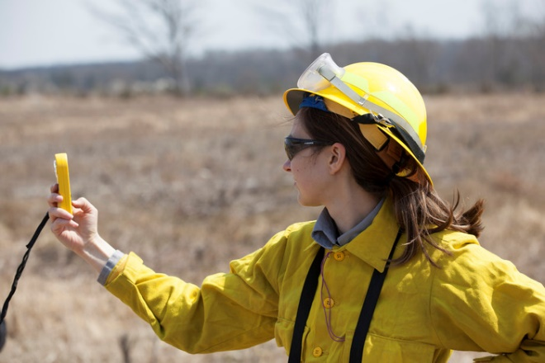

A wildland firefighter holds up an anemometer to test the wind speed. NPS/Nathan King

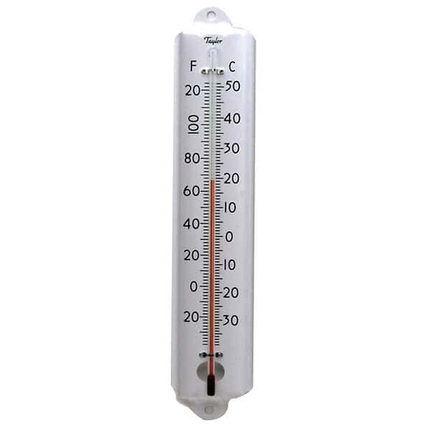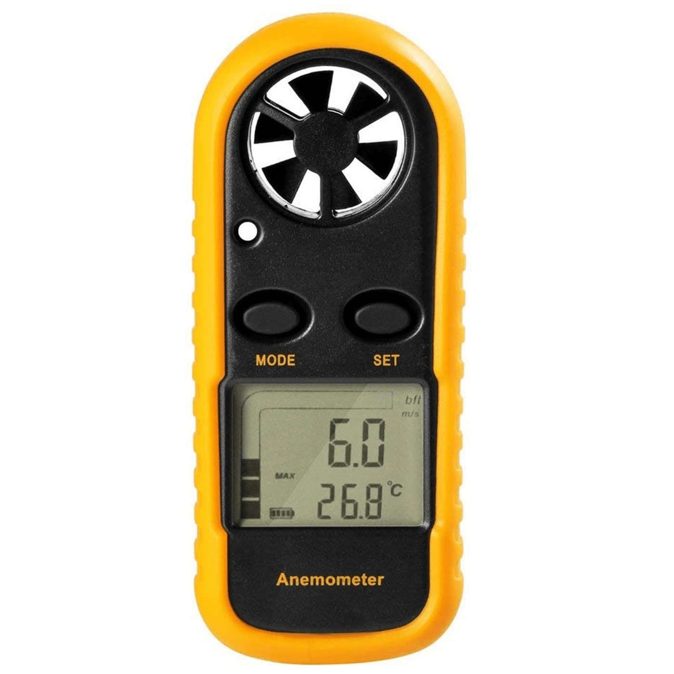

Thermometer

Anemometer

# **Resources**

Chapter Introduction: Fire Ecology. blm.gov

Parasitic plants can amplify forest vulnerability to climate change. Pacific Northwest Research Station. US Forest Service. 2020

Francisco Tutella. Fire operations-prescribed burning combo reduces wildfire severity up to 72%. Penn State University. 2021

*Prescribed Burn: Techniques; Tips On How To Do Controlled Fires*. Geospatial Data Analytics, GIS Software, Satellite Imagery In EOSDA. (2022). Retrieved January 9, 2023 from https://eos.com/blog/prescribed-burn/#ref-3.

*Managing Fire | US Forest Service*. Home | US Forest Service. (2022). Retrieved January 9, 2023 from https://www.fs.usda.gov/science-technology/fire.